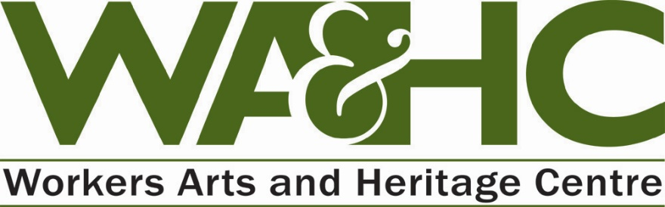
51 Stuart Street | Hamilton, ON | L8L 1B5 | 905.522.3003 | http://wahc-museum.ca/

REGISTRATION FORM – May Day All Ages Instrument-Making Workshops
Friday, April 29th, 2016 7-9 pm
Saturday, April 30th, 2016 9am – 3 pm

Participant’s Name:___________________________________________________________________
Name of Parent or Guardian (if applicable):________________________________________________
Address:_______________________________________City:_____________ Postal Code:___________
Telephone:______________________Email:_________________________________________________
How did you hear about this program at WAHC?______________________________________________
Waiver of Likeness

- I agree that any photo (whether electronic, digital or otherwise) taken of me or my child or in which my child or I will appear may be used by WAHC for any purpose including publicity, publications and video productions, without compensation to me/my child, and this constitutes my consent to such use. I understand that neither I nor my child will be identified by name.

Name:_________________________Signature:__________________________Date:______________

PAYMENT
$10.00 (total fee for all materials included in Friday and Saturday workshops)

Method/Amt. of Payment: Visa________ Mastercard_________ Cash________ Cheque__________
Account Name:________________________Account Number:__________________________________
Expiry Date:_______________________CVV#____________Signature:___________________________
Full payment must be included with registration form. NO REFUNDS WILL BE ISSUED AFTER REGISTRATION IS COMPLETED.

Please email, mail or drop off registration and payment to: WAHC, 51 Stuart Street, Hamilton, L8L 1B5. For more information, contact: Tara Bursey, Programming Coordinator (905) 905-522-3003 tara@wahc-museum.ca

